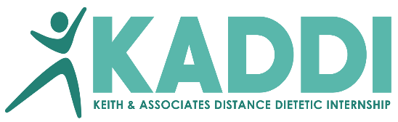 |  |  |  | FACILITY FORM
Intern Name:
Facility Name:
Street:
City, State, Zip
Website:
Printed name of contact for affiliation contract
Phone: |  |  |  | FAX:
Email (print):
Printed name of person completing this form:
Email of person completing this form:
Phone for person completing this form:
Which rotation(s) will be done at this facility (mark all that apply below)
Nutrition Therapy |  | Foodservice |  |  | Community |  | Business & Entrepreneurship
Type facility:  ___ acute care  ___ skilled nursing / rehab  ___ dialysis  ___ outpatient clinic  Type: ___________________  Conditions:  ___ overweight/obesity  ___ diabetes / endocrine  ___ cancer  ___ malnutrition  ___ cardiovascular  ___ gastrointestinal  ___ renal  ___ respiratory  ___ other _____________  Is there a Registered Dietitian available to supervise intern?  ___ yes ___ no |  | Type facility:  ___ school  ___ acute care  ___ rehab / long-term care  ___ other __________  Type operation:  ___ conventional  ___ cook-chill  ___ room-service  ___ commissary  ___ other:  Number of employees/FTEs  _________ meals served daily  (minimum of 60/day) |  |  | Type facility:  ___ school  ___ WIC  ___ public health  ___ Coop Extension  ___ SNAP education  ___ Head Start  ___ senior nutrition  ___ employee wellness  ___ outpatient clinic  Type: |  | Type of business:
For questions, contact the internship director at KADDI@consultingdietitians.com or 918-574-8598

